**People Counting System**

Technion - Israel institute of technology

CS 234329 - Project in Image Processing and Analysis

23 February 2020

# Abstract

This paper presents the development and details for use of a people’s counting system, able to count the people entering and exiting a specific zone from a live stream video feed obtained from IP cameras in real-time.

This goal is achieved by the combination of two components: a detector component using a Convolutional Neural Net (YOLO) detecting people on the frame, and a tracking component utilizing a tracking algorithm (CSRT) which updates those people positions on the next frames.

This system was built for the Technion’s libraries to monitor the number of people in the libraries at any given time but is highly configurable and can fit different types of buildings and entrances.

|  |  |
| --- | --- |
|  | Figure 1 - Architecture library counting |
|  | Figure 2 - Mechanical library counting with ROI |
|  |  |
|  |  |

# **Table of Contents**

Abstract 1

**Table of Contents** 2

Introduction 4

The Technion libraries architecture 5

System Implementation 6

System Design 6

Full flow 7

**In-depth Flow** 8

**Track_and_detect** 8

**Handle_Object** 9

**Detect** 11

System’s parameters 13

Input 13

Counting 13

Detection 15

Tracker 17

Output 18

Manual: How to? 19

How to set a new “ROI” polygon? 19

How to set up a new camera? 20

How to debug? 22

System Improvements - Developing from Experiments 23

The Detector: Mask R-CNN vs. YOLO 23

Experiments on both detectors and conclusion 23

Counting line \ ROI 24

Tracker and Detector failures 25

“Detection Slowdown” mode 27

Detection ROI 27

Object liveness areas – a remedy to ‘bouncing boxes’ 29

Abnormal bounding boxes handling 31

Tests and Results 32

Benchmark test videos 32

Results 32

In depth analysis 33

Performance analysis 34

Speed 34

Stress test and functions timing 34

Overview of algorithms and models used 36

YOLOv3 (You Only Look Once version 3) 36

Mask R-CNN 38

Centroid Tracking Algorithm 39

CSRT Tracking Algorithm 40

Conclusions 41

Further Work and Suggestions 41

References 41

# Introduction

In the near past, the ability of identifying people and tracking them in a video, and doing so in real-time was very challenging: it required a lot of computational resources and was immensely hard to develop.

With the rapid development of neural networks in recent years, this task became more plausible for general use, and could be applicable to solve many problems.

One such problem is counting the amount of people entering or exiting a building through specific entrances.

A counting system intended for this problem could add value for various different scenarios (knowing the amount of people in a building in case of an emergency, allocating an area’s resources according to how populace each building or floor in it is etc…).

Our project focused on entrances to the Technion’s library buildings throughout the different faculties.

In this paper we will present:

1. The system’s implementation.
2. An in-depth user’s manual.
3. The development stage with improvements made to solve issues arisen from experiments.
4. Tests and results – how accurate is the system we built.

# The Technion libraries architecture

The library today performs the people counting task using the following architecture:

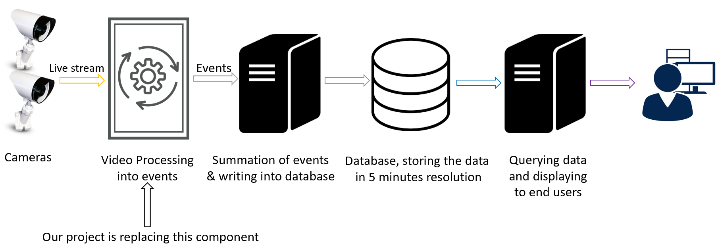

Figure 3 - Architecture of the library's people analytics

1. IP cameras are located overhead in the libraries entrances and send live stream video
2. A video processing component (already existing today) gets this live feed from the cameras, processes it and translates it into count events: ins and outs.
3. The events are sent to a summation system, that sums the ins and outs and sends them to the database every 5 minutes
4. The database stores the data in 5-minute resolution
5. The data is made available for queries and displayed to the end users

The current state of the architecture suffers due to large inaccuracies in its counting capabilities, as can be shown in this daily counting graph:

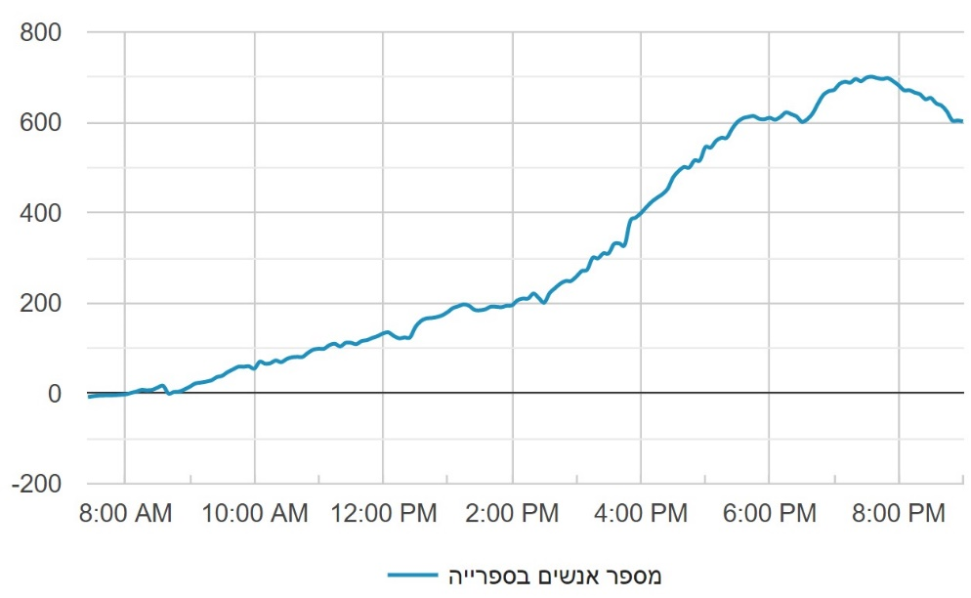

Figure 4 - Amount of people in the library daily according to current architecture

The blue line represents the number of people within one of the Technion’s libraries, from its opening until its closing (when there are no more people left within it). As can be seen, while the library should be empty and contain 0 people, the system believes there are around 600 – which goes to show the inaccurate counting of the video processing throughout the day compounding to this level.

These inaccuracies are what this project aims to remedy by replacing the video processing component with our counting system.

# System Implementation

## System Design

In this chapter we will view in depth the code flow of the counting system.

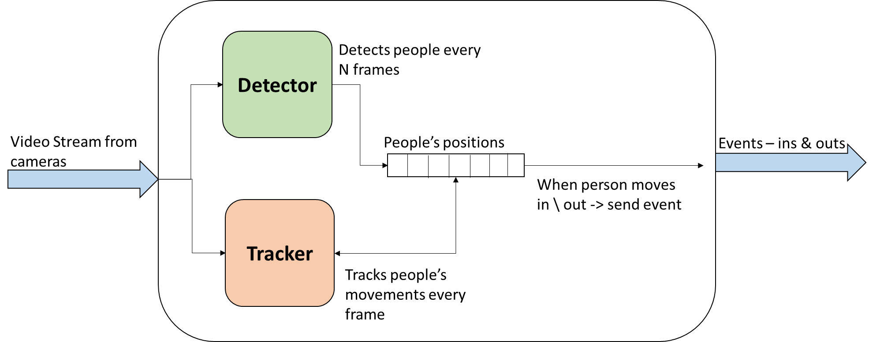First, a short overview of the system:

Figure 5 - System's general scheme

Input & Output: The system receives a video stream from the cameras, and outputs events whenever a person was detected entering or exiting the entrance (with the corresponding “in” or “out” event).

Internally, the system has two main components:

1. Detector: a component detecting objects it classifies as human (implemented with YOLOv3), and either identifies them as objected already detected in the past (in which case their positions will be updated) or as new objects (and then adds new objects to the people’s positions array).

The detector attempts to make detections only every ‘N’ frames in order to lower the computational cost of the system.

1. Tracker: this component tracks the locations of already existing people (previously detected by the detector) and updates their positions in the array. Implemented by Open-CV’s CSRT tracker algorithm.

In our implementation, each person has his own tracker object.

Every time a person has changed his position from the entrance exterior region to the interior region (which is marked by a line or polygon), a counting event occurs and an “in” or “out” event is sent from the system.

We will now explain the system’s code flows (mentioning its files and most important functions).

### Full flow



Figure 6 - Full flow of the counting system

The counting system starts in the “main” file.

It receives an “.env” file that contains all the configurations needed for the system (the configuration parameters will be explained in the “System parameters” section).

The main file is in charge of parsing all the parameters from the configuration file and validating them.

After parsing the parameters, “main” then starts a live connection to the required camera.

From this point, live stream enters the system and are sent by “main” to the **FrameProcessor** component, frame by frame.

The FrameProcessor component will send each frame to 2 main functions:

* + - 1. **Track_and_detect** – will detect objects each X frames (configured parameter that called “DI” [Interval Detection]), track existing objects and finally will count the objects that entered and exited from the library.
      2. **Visualize** – will create visualizations on the frame (in accordance with the configurations made):
         1. Object bounding boxes.
         2. Line/ROI that separates the “In” zone and the “Out” zone.
         3. Detection area (“DROI”).
         4. Objects “Liveness area”.
         5. Amount of people that enter and exit the library.
         6. Frame per seconds (FPS) rate.

### **In-depth Flow**

#### **Track_and_detect**



**Track_and_detect** function purposes are:

Track existing objects and update their positions.

Detect new objects.

Count object if it enters / exits the library.

Send IN / OUT event.

The FrameProcessor component holds a list of all the objects that exists.

First, Track_and_detect will perform the Handle_Object function for each existing object.

Handle_Object will track the object, update the object location and count it if needed.

Second, Track_and_detect will check if the amount of frames since the last detection has passed the Detection Interval (DI) limit, and if so will perform the Detect function.

The **Detect** function will run the detector model and detect the objects on the frame, will add new objects \ update existing ones.

Finally, if no object exists in the frame, the detector’s confidence threshold will be decrease in order to be more sensitive to new objects emerging in the next frames (as part of the “Detection Slowdown” mode explained later).

##### **Handle_Object**



**Handle_Object** does the following:

1. Runs the object’s tracker.
2. If the tracker succeeded, it will check if the object is located in the detection ROI (DROI).

if so, the location of the object will be updated. otherwise, it will increase the tracker failure (points that the object might have left the frame).

1. Will check if the object has transitioned from the area it was first detected to the other one (e.g. In -> Out), and wasn’t counted yet. If so, it will count the object and send an event.

The separation between the areas can be by a line or ROI (area of the inside / outside of the entrance).

##### **Detect**

The **Detect** function has two main goals:

1. Detect objects on the frame and validate them.
2. Add the detected objects to the objects list (as new objects or update existing ones).



The detection procedure:

The detection itself is performed by a YOLO model’s predict function that was implemented by Keras (with a Tensorflow backend).

The predict function gets as input an image and an area on it that it needs to detect from (DROI) and outputs the detected objects.

It will choose the objects that:

* Have higher confidence than the confidence threshold.

Purpose: choose only the object that we are sure about.

* Smaller than the maximum object size threshold (measured as a percentage by Box size / frame size)

Purpose: Avoid objects too big (unlikely to be human)

* Ratio between the height and the width smaller than the maximum object ratio.

Purpose: Avoid objects with abnormal shapes (unlikely to be human)

* The center of the object is in the detection ROI (DROI)

Purpose: Detect only objects where they should be

* Smaller overlap with objects with higher confidence than the IOU threshold

Purpose: Avoid object duplication.

**The inserting of the detected object procedure:**

In this stage we want to decide for each detected object if it’s a new object in the image or an old object that moved and needs to be updated.

In addition, we want to remove the objects that have left the frame.

How do we do that?

In order to decide if this object already exists we will check if the object has high overlap with one of the existing objects. If so, we will update the existing object.

In order to remove objects that left the frame, we will hold a counter of the detection failures for each object. We update the counter every time the object wasn’t updated by the detection procedure. When the amount of detection failures become higher than the threshold (MCDF), the object will be removed because it has probably left the frame.

Lastly, existing objects having high overlap can be deduced as the same object, so we will remove them (leaving only one) to avoid duplicates.

## System’s parameters

The system’s parameters purpose is to configure the system to the relevant camera, and the way the counting system makes its detections and tracking of the objects.

The system’s parameters are divided into 5 categories:

### Input

Configures the input of the system.

We have 2 options for video input:

1. Local video file – file that is located in the computer.
2. Live stream – Internet connection to the camera that gets live frames.

Parameters:

* **Is_cam** – Flag that specifies if we want to set as input live stream or a video file.
* **Video** – the path of the video file.
* **Connection** – live connection to the camera.

Example: “rtsp://<username_of_camera>:<password_of_camera>@<ip>:<port>/h264_stream”

### Counting

Configures the counting method, the counting area / line and the liveness area of objects.

Counting methods: we have 2 counting methods:

1. **Count by ROI** - (Region of Interest). Count all the objects that passed from / to the ROI.

**Example** - How is it done? (Assuming that the ROI is the area outside the library)

The object enters the library: if the object’s first detection was in the ROI and the current location is not in the ROI.

The object exits from the library: if the object’s first detection wasn’t in the ROI and the current location is in the ROI.

Count by ROI Parameters:

* **Counting_roi**- Specifies a counting region of interest. (A set of vertices that represent the area where you want counting to be made).

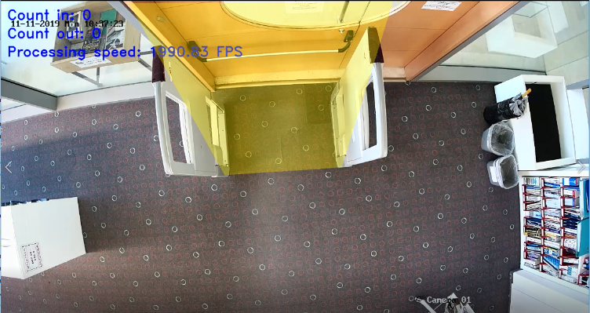[1]

Figure 7 - Example of using counting ROI – use it when the entrance of the library is not straight.

* **Use_count_roi** –flag for enable counting by roi and not by line. If False- will count by line.
* **Show_count_roi** – Disable/overlay the counting roi on the video.
* **Counting_roi_outside** – orientation of counting region (True – the region is the outside area, False – the region is the inside area).

1. **Count by line** – count all the objects when they pass a line.

**Note** that the line is only for display, and marks a position on the X \ Y axis. The object doesn’t have to be tracked or detected directly on the line, just on the two sides of it.

**Example** - How is it done? (Assuming that the right side of the line is the outside of the library)

The object enters the library: if the object’s first detection’s x coordinate was right of the line and the current location’s x coordinate is left to the line.

The object exits the library: if the object first detection’s x coordinate was left to the line and the current location’s x coordinate is right of the line.

Count by line Parameters:

* **Counting_line_orientation** – orientation of the counting line (top/bottom/left/right). If right – all object that are right of the line are considered outside the area.
* **Counting_line_position** – position of counting line, needs to be a float number between 0 to 1. The line will be in the position*width of the frame.

Liveness area of objects:

An object “liveness” ROI.

This simple ROI should cover most of the frame, except for a narrow strip next each of the exits from the frame. Whenever an object that was already counted leaves the liveness zone, it is discarded.

You should configure this area as far as you can from the counting line in order to avoid counting object that was discarded but by a small chance detected again in the area outside the liveness area.

Parameters:

* **Object_liveness_roi** – set of vertices that represent the area which within counted objects will not be discarded.
* **Enable_object_liveness** – enable the liveness feature.
* **Show_object_liveness** – draw the liveness ROI on the video.

### Detection

DROI:

DROI (Detection Region of Interest) – a polygon that includes the only areas detections are plausible from.

For each frame extracted from the video, before being sent to the detector, the area outside the DROI polygon get masked to ensure detections will not be made there. Additionally, if the tracker returns that an object has entered a zone outside of the DROI, it will be considered as a failure.

The DROI is intended for zones that are impossible for human movement (like book-shelves, walls or fixed inanimate objects).

Parameters:

* **Use_roi** – Enable / Disable detection by region.
* **DROI** – set of vertices that represent the area (Polygon) where you want the detection to be made.
* **Show_droi** – Display / overlay the detection ROI on the video.

DI

DI (Detection Interval) – This is a number that dictates the amount of frames between every 2 detections to be made.

The lowest possible DI is 1. Generally, lower DI will result in more accurate detections but will slow down the system more.

The DI has a correlation with FPS. If the FPS is lower, then the DI should be lower.

(Our tests and parameters were adjusted for 12 FPS)

Parameter: **DI**

MCDF

MCDF (Maximum Continuous Detector Failure) - the amount of detection failures until the object will be removed.

In order to remove objects that have left the frame, the system holds a counter of the detection failures for each object. We update the counter every time the object wasn’t updated by the detection (the detection procedure as explained earlier didn’t detect this object). When the amount of detection failures becomes higher than MCDF, the system will remove the object because it has probably left the frame.

Higher MCDF values allow the tracker to significantly support the detector.

The smaller the camera zoom is, the higher MCDF should be – because it will be longer until the object will leave the frame (increasing the probability for higher streaks of detection failures).

If the line is positioned far from the center of the frame, MCDF should be higher – because it will take longer for the object to reach the line (and if the object was only detected once when it entered the far side of the frame it will need MCDF high enough for the tracker to support it all the way to the line).

Note that high MCDF values may result in a phenomenon we call a “bouncing box”. It happens when an object leaves the frame, and the tracker makes bad attempts to locate where the object has gone to next. It will continue to bounce the box locations around until the MCDF count is depleted.

Parameter: **MCDF**

IOU_threshould:

The Threshold above which 2 objects detected will be considered as the same object and the one with the lower confidence will be removed.

Parameter: **IOU_threshould**

Percentage_of_frame_threshold:

The threshold of bounding box size (measured as a percentage of the frame’s size) above which a detected object is removed.

Recommended values depend on the camera’s zoom. The larger the zoom is, the higher the threshold should be.

Parameter: **Percentage_of_frame_threshold**

Maximum_width_to_high_ratio_allowed:

The maximum ratio allowed between width and height of a box, ensuring only proportionate bounding boxes. Value mast be larger than 1.

Parameter: **Maximum_width_to_high_ratio_allowed**

Detection_slowdown:

This mode, when turned on, has two phases:

1. Phase 1: When no people were detected on screen, detections would behave as usual in terms of timings (detect every DI frames), but detection confidence is doubly more sensitive than usual (so that the detector would more easily detect objects).
2. Phase 2: While at least one person is detected on the frame, the DI is decreased to “1”, and the confidence threshold is returned to normal.

Parameters:

* **Detection_slowdown** – enable/disable the feature.
* **Sensitive_confidence_threshold** – A sensitive confidence threshold meant to be lower until the first detection occurs. It relevant only when the Detection_slowdown is enable.

YOLO_model_path:

The path of the yolo h5 model file. This path can be replaced by tiny-yolo / other yolo versions easily (or other detectors inputting and outputting the same format). It has to be an h5 file.

Parameter: **YOLO_model_path.**

Confidence_threshold:

All the detected object with lower confidence than this threshold will be removed.

Parameter: **Confidence_threshold.**

### Tracker

Tracker:

Configure the algorithm to use for people tracking.

There are a lot of trackers implemented in Open-CV. We have used only CSRT.

The supported trackers (**not fully tested**) – kcf, csrt, medianflow, mosse, tld, goturn.

Parameter: **Tracker.**

MCTF:

“Maximum Consecutive Tracking Failures”, the number of tracking failures before the tracker concludes the tracked object has left the frame.

The tracker can fail after the track function (if the tracker itself failed) or if the tracker returns an object not in the detection ROI.

Parameter: **MCTF.**

Overlap threshold:

When a new detection is made overlapping with an existing person, the minimum overlap threshold to correlate the existing tracked person to the newly detected one (deducing they’re the same person).

Parameter: **Overlap threshold.**

### Output

Record:

Enable / disable the recording of the video with the people counter output.

Parameter: **Record.**

Output_video_path:

The path where the video record will be stored.

Parameter: **Output_video_path.**

UI:

Run the system with UI display.

Parameter: **UI.**

Logging:

The logger of the system creates messages that contain the events occurring during the running of the system. i.e.: object creation / deletion.

Parameters:

* **Enable_console_logger –** Enable / disable the logger messages into the console.
* **Enable_file_logger –** Enable / disable the logger messages into file.
* **Log_file_directory -** The path where the log file will be stored.

Debug_window_size:

Size of window UI.

Parameter: **Debug_window_size.**

Color_change_interval_for_counting_line:

The amount of frame that the color of the object and the counting roi/line will be different from the moment the object was counter.

Parameter: **Color_change_interval_for_counting_line.**

DEBUG-

Enable/disable debug mode. Debug mode has the ability to control the video procession (pause/stop), get pixel positions and display the UI.

Parameter: **DEBUG.**

## Manual: How to?

### How to set a new “ROI” polygon?

Do the following steps:

1. Run the system on “debug” (Enable the DEBUG parameter). It is recommended to pause the video.
2. Mouse click on the polygon’s vertices you want to set.
3. The pixel positions for those vertices will be shown in the console log.
4. Order the pixel position from left to right into a list.

For example: [(the top left point), (the bottom left point, (the bottom right point), (the top right point)].

1. Add the pixel list to the env file.
2. Enable the show flag for that specific ROI in the env file in order to verify the polygon.

**Example**

We want to capture the tile from the floor as a polygon.

We first click on the mouse click 4 times (where the cursors are marked in the photo):

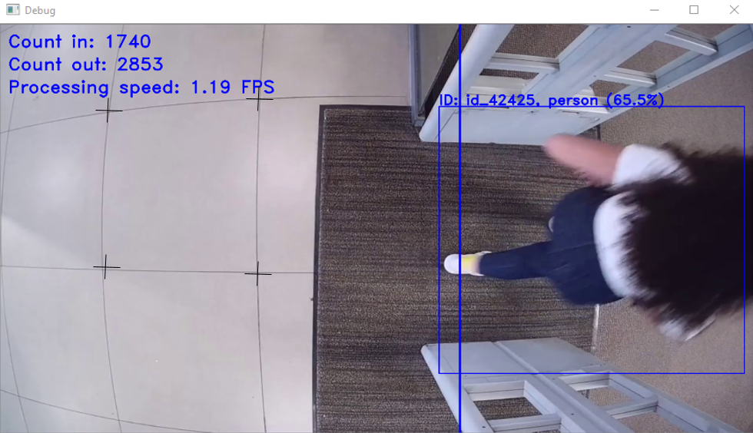

We got the following positions:

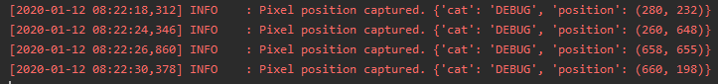

We order the pixels:

[(280,232), (260,648), (658,655), (660,198)]

We added the pixel list to the env file and enable the show polygon flag:

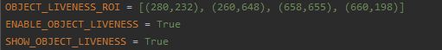

The polygon now looks like this:

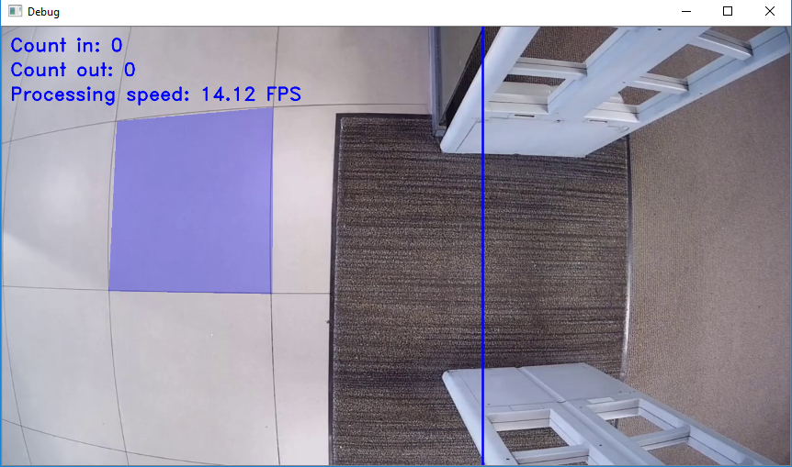

### How to set up a new camera?

1. Run the system on “debug” (Enable the DEBUG parameter).
2. Configure the camera connection in the env file. (change the IP / port / protocol)

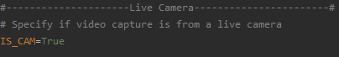



1. Decide how to count
   1. Count by Line –
      1. Disable the counting by ROI flag in the env file –



* + 1. Configure the counting position-

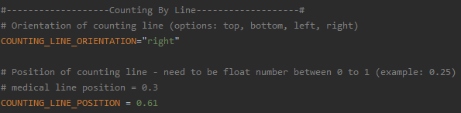

Try to locate the line in the center of the frame (closer to 0.5), and in the middle of a physical bottleneck if one is possible.

The line orientation should be the “out” area by the line.

* 1. Count by ROI-
     1. Enable the counting ROI flag:



* + 1. Configure the counting ROI polygon

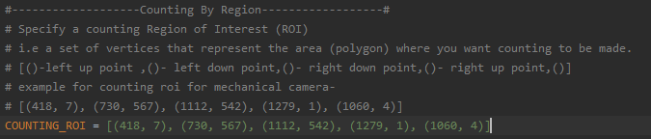



1. Object liveness:

Configure the object liveness polygon and enable \ disable the flags

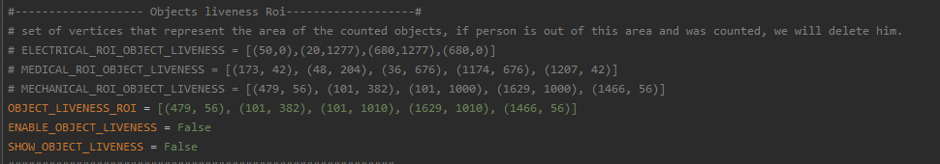

1. DROI:

If you want to use detection ROI, configure the polygon and enable \ disable the flags.

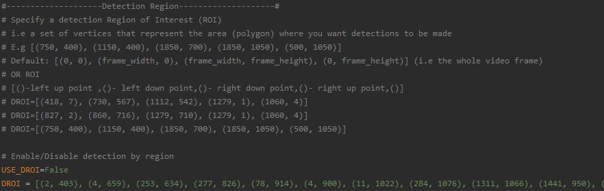

1. Find the best MCDF for the camera by testing and configure the MCDF:

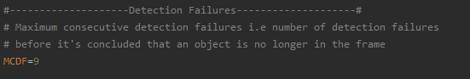

1. DI:

configure the DI to the required interval (for 12 FPS, DI of 3 is recommended).

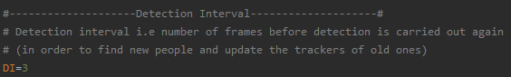

### How to debug?

In order to debug the system, you need to run the program in the debug mode (Enable the DEBUG parameter).

* You can pause / stop the video stream by clicking on “P” or “Q”.
* You can use the logs and debug the events that occur during the system running.

The logs of the system include 2 types of messages:

1. Error messages – when the validation of the system parameters failed.
2. Information messages – inform about creation of a new object, updates to the position of an object, count event of an object, deletion of an object, pause / stop the video stream and the captures of the position pixel.

# System Improvements - Developing from Experiments

This chapter will present the improvements we have devised to the system from the bulk of failed experiments we have made over its development, back from its initial logic.

We based most of our experiments using the benchmark video tests we were given from the Technion’s Library (more details in “*Tests and Results*”).

Initially, the logic of the system was simple: Have a detector detect objects (new and old) every DI (Detector Interval) frames, and have the tracker track the movement of those objects every frame. Both have failure limits: MCDF (Maximum Continuous Detector Failure) and MCTF (Maximum Continuous Tracker Failure), and attempt to cover for each other’s failures.

People are tracked from the moment they are first detected, and are counted when they cross some line.

## The Detector: Mask R-CNN vs. YOLO

The first question we’ve asked ourselves is which detector we should use:

1. **Mask R-CNN**: A much more accurate detector (by every metric measured), but heavy on computational resources. Our hopes for it were that it would rarely miss a detection and thus provide the tracker good inputs to follow, and that it would perform better with occlusions scenarios (two people walking next to each other would be truly detected as two separate people).
2. **YOLO**: A more lightweight approach with good accuracy. Since it takes less computational resources, we could then activate it more often (decreasing the DI parameter), and this way helping correct tracker issues. We were more inclined towards this option since, if it does the job needed – it’s better to provide a product that has lower computational requirements.

### Experiments on both detectors and conclusion

We have used implementations of both detectors using Keras (with Tensorflow backend).

1. *Speed:*

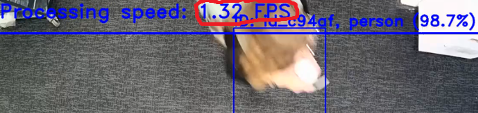The first issue that has deemed Mask R-CNN unfit for the task is its very low speeds. While YOLO performed well in real-time, Mask R-CNN worked at an average of 2 FPS. This is **completely impractical** for real-time uses.

Figure 8 - Slow FPS when Mask R-CNN makes detections

1. 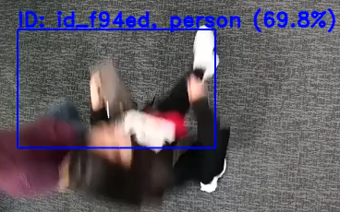*Occlusions:*

Testing on the two clear occlusion cases where YOLO had failed from the benchmark video tests, the Mask R-CNN had not performed any better.

1. *Detecting issues:*

Figure 9 - Occlusion case, detection made by Mask R-CNN

While both detectors had their share of detecting issues, Mask R-CNN had a few unique issues of its own:

1. 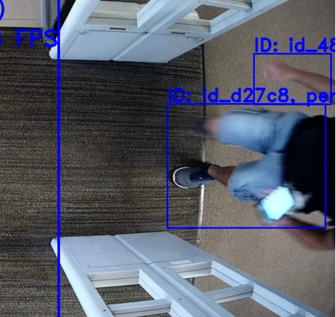Its high accuracy caused one person to be detected as several by different body parts. There are ways to treat this normally, mainly filtering out bounding boxes that have an overlap above a certain threshold. But we have witnessed special cases where there was no overlap at all.

And when two objects were detected rather than one, they were than tracked well by the tracker until being counted – meaning a person was counted twice.

1. Sometimes inanimate fixed objects in the frame would be detected as people by Mask R-CNN. That strange and unexpected occurrence happened even when the detector’s confidence threshold was above 70%.

Figure 10 - Two body parts detected as different people by Mask R-CNN with zero overlap

All of the reasons above, with the speed issue had averted our efforts from Mask R-CNN to YOLO as a detector completely. All following improvements and experiments were made after that decision, making the system more tailor-made to YOLO.

## Counting line \ ROI

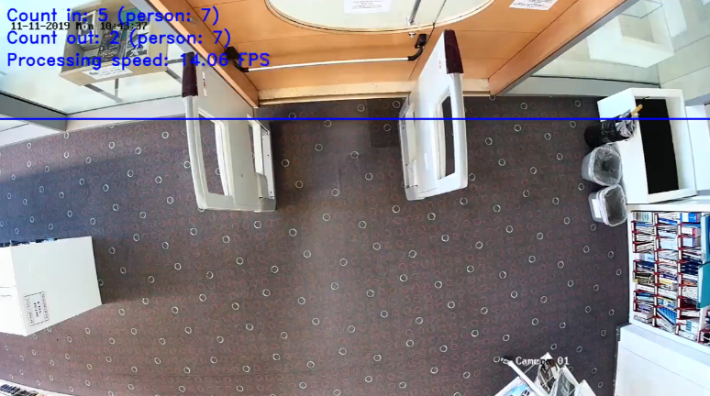Every library entrance should be divided to two regions: the “in” (where people come out of or into) and the “out”.

Our first idea was using a counting line for every library as a mark to where one region starts and one region ends. The line would indicate which axis splits these regions: The X axis or the Y axis.

Soon enough we encountered the issue of libraries where the two regions could not be conveniently separated by a single line on one of the axes.

Instead, we decided to implement a “counting ROI” for such cases (or cases which might benefit from such a geometry). The “counting ROI” is a polygon composed by different dots on the frame and lines connecting them. Every time an object’s location is determined (either by the detector or the tracker), its centroid is calculated. If the object originated from outside the polygon but is now within it, a counting event occurs (and vice versa from inside to outside). The polygon can be configured as both “in” and “out”.

Figure 11 - Mechanical Engineering entrance. should people going to the umbrella (right upper corner) be counted out?

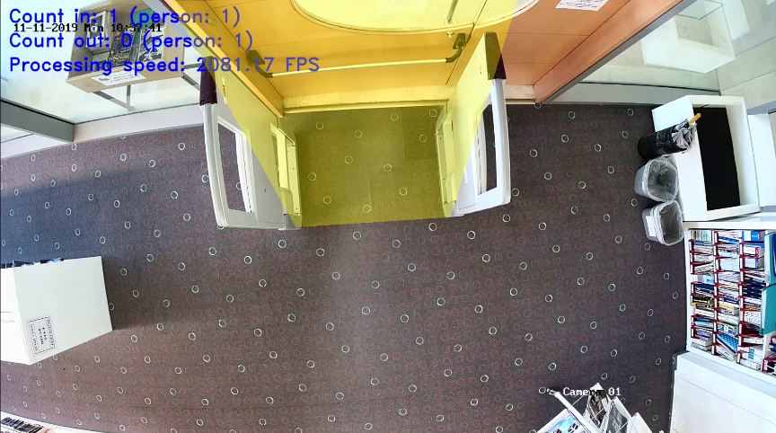An additional issue we wondered about is where the line should be located on the frame. Quite intuitively, the correct spot is as close to the middle of the frame as possible. That’s because the detector might fail when an object first enters the frame, but might succeed in the following frames. Pushing the line to the middle gives it another chance in the form of more frames to detect in.

Figure 12 - Mechanical Engineering entrance with a counting ROI

Another helpful intuitive factor is locating the line (or ROI) in the narrowest physical bottleneck, making occlusion cases rarer (because people can’t stand next to one another when they pass through the bottleneck).

## Tracker and Detector failures

Initially when running our system on the benchmark video tests, we could identify two main issues, and found solutions to improve their severity:

* Tracker failures – These occurred when the tracker lost the person it was trying to track over the frames.

**Solutions**:

1. Using a more sophisticated tracker improved results dramatically (using CSRT rather than centroid)
2. Lower DI (Detection Interval) values allow more support and corrections from the detector.

* Detector failures – These happen when the detector fails to recognize a person in the frame. This is mostly an issue when the detector doesn’t succeed up until the point that person crosses the counting line and will not be counted.

**Solutions:**

1. Lower DI gives more chances for the detector to detect the person before the counting line is crossed.
2. Lowering the detector’s confidence threshold, which is the parameter that regulates how confident the detector must be before announcing an object is a person, will allow more successful detections.

Even if a low chance exists for a false-positive, the risk of the tracker tracking it & the detector detecting it again in the following frame approaches zero.

1. High MCDF (Maximum Continuous Detector Failure) allows the tracker to **significantly** support the detector.

There were many instances where the detector failed to detect the person for more than one frame, but the tracker did a great job to track it through the frames. With a low MCDF, the tracking would forcefully stop just because the detector couldn’t detect the same object again. A higher MCDF prevents that and allows the tracker to track the person long enough for the counting line to be crossed.

The solutions above have significantly lowered the amount of detection & tracker failures, but there were many instances it wasn’t enough. Those failures are what lead us to devise a “Detection Slowdown” mode, which fixed them completely.

## “Detection Slowdown” mode

The remaining detector and tracker failures lead us to think in new ways to reach a solution.

The idea for this mode was modelled by the way we ourselves have looked for people in the videos:

When looking for a person we would run the video at very high speeds. Whenever we’d see any movement, even a shadow, we would immediately stop the video, decrease its speed and look more closely.

What if, we thought, the system could do the same as us. And that’s how the idea came to be.

This mode, when turned on, has two phases:

1. Phase 1: When no people were detected on screen, detections would behave as usual in terms of timings (detect every DI frames), but detection confidence is doubly more sensitive than usual (so that the detector would more easily detect objects).
2. Phase 2: While at least one person is detected on the frame, the DI is decreased to “1”, and the confidence threshold is returned to normal.

Phase 1 sensitive confidence threshold makes detection failures rare. Even if a false detection is made, phase 2 will remove it by increasing the confidence threshold and by attempting to re-detect the object every frame, which would most likely fail if it wasn’t a person.

Having a DI at value “1” is of course optimal in terms of accuracy because we utilize the detector to the fullest to assist the tracker.

We can’t always remain at such a low DI and also remain in real-time speeds, however if we limit such lags to only the most critical moments, the system could make up for the lost time in the rest of the time. That is, we allow the system to experience lags, but only **temporarily**.

The most critical moments are when there are people detected on the frame – we want to be able to count them correctly, and that’s exactly why a detection is the trigger to move to phase 2.

The rest of the time we might have many empty frames – these could be dealt with fast in phase 1, going over them and catching up to the present moment.

The results when using the “Detection Slowdown” mode were astounding, raising accuracy to almost perfect scores on the benchmark test videos.

## Detection ROI

Low detection confidence is a double edged sword – as said above it could on the one hand improve accuracy significantly, announcing objects as human even if the confidence measure is low. On the other hand, it could also identify inanimate objects as people.

Combined with a proximity to the counting line and the tracker mistakenly detecting a movement of that object over the line and we’d get a false-positive counting.

With a “Detection Slowdown” in place, this would have a more severe effect slowing down the DI every time, discover the detection wasn’t human (now with a higher confidence threshold), and then moving to the lower confidence threshold again (with higher DI) just to find that same object all over again in a loop.

This is acceptable if that strange object was temporary in the frame and move with a person next to it (like a backpack, a cart etc…), but when it is fixed in place it causes lags and slowdowns when they aren’t necessary.

Figure 13 - A false detection made on an inanimate object

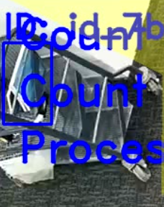

The way we devised to deal with this is defining a “DROI” (Detection Region of Interest) – a polygon that includes the only areas detections are plausible from.

For each frame extracted from the video, before being sent to the detector, the area outside the DROI polygon get masked, and detections will not be made there. Additionally, if the tracker returns that an object has entered a zone outside of the DROI, it will be considered as a failure.

The DROI is intended for zones that are impossible for human movement (like book-shelves, walls or fixed inanimate objects).

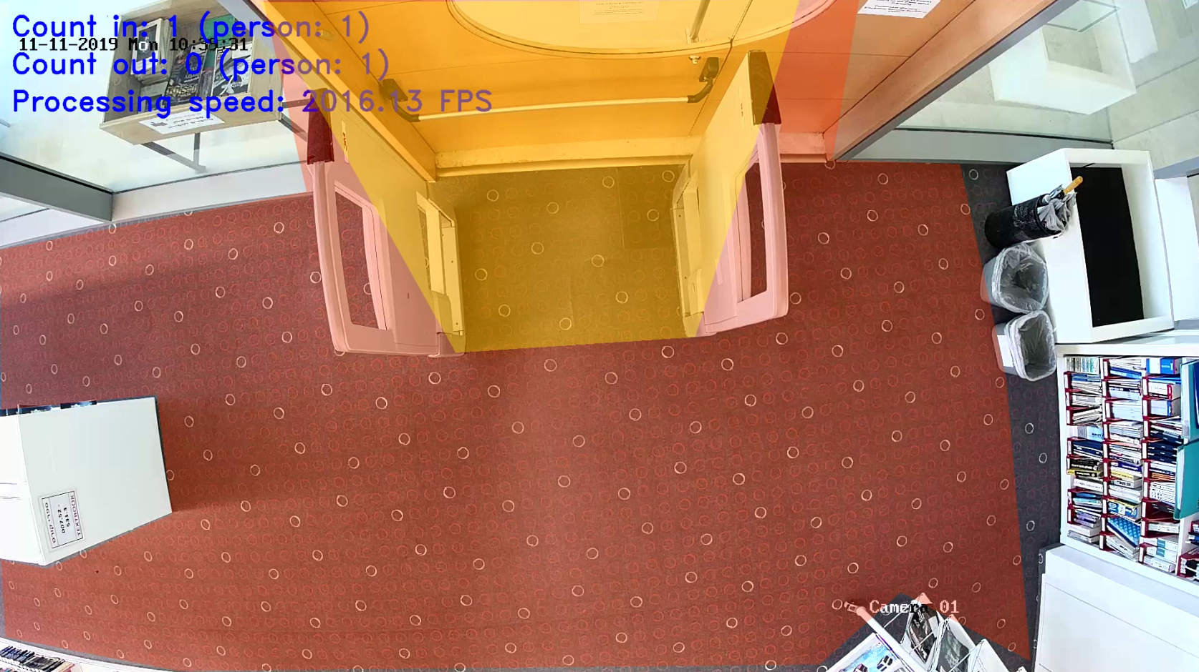

Figure - A DROI in Mechanical Engineering library. The red - orange polygon marks the DROI, objects outside of it won't be detected or tracked. Here we can see an added benefit: people peeking from outside the glass walls will not be detected or tracked.

## Object liveness areas – a remedy to ‘bouncing boxes’

The more detections made, the higher the MCDF parameter should be (the amount of detector failures that are tolerated before the object is removed). We have previously talked about how adjusting this parameter to relatively higher values solve detection problems.

With the “Detection Slowdown” mode in place however, the amount of detections is increased to every frame whenever there are objects detected, further requiring to increase MCDF.

High MCDF comes at some cost however: when an object leaves the frame, the tracker might fail and think it’s still in the frame. This results in the video seeing the bounding box beginning to bounce around until the remaining detector failures deplete, a “bouncing box” if you will.

This might prove to be an issue if by chance the bounding box locks on a new person (this is **not** an issue with the counting line if the box locked on the person well since crossed the counting line, because boxes will not be counted more than once).



MCDF

Higher values

May result in ‘Bouncing Boxes’

Lower values

May result in people not reaching the counting line (and not counted)

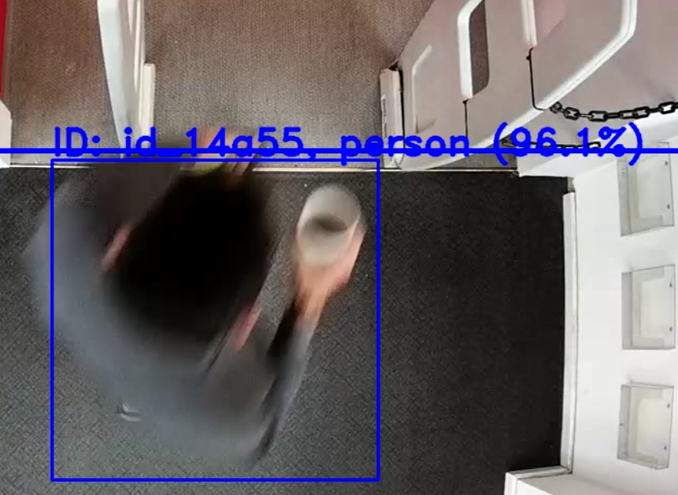

Bounding box is removed due to MCDF threshold before reaching the line

To solve this issue, we created one final ROI – an object liveness ROI.

This simple ROI should cover most of the frame, except for a narrow strip next to the exits from the frame. Whenever an object that was already counted leaves the liveness zone, it is discarded.

This solution works however only if the person was successfully tracked since being counted until it exits. Otherwise, it will not discard the person (because it might be a new person coming inside).

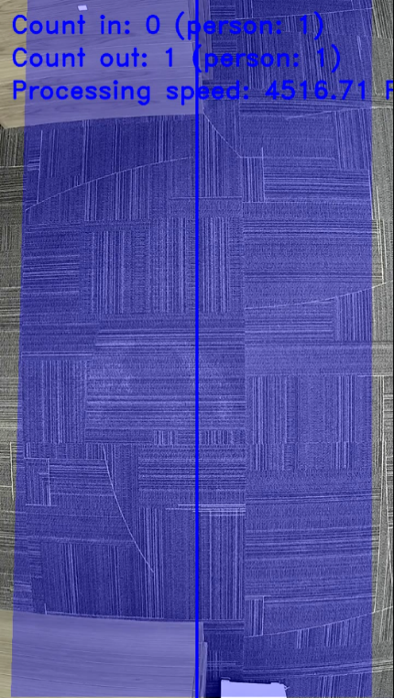

Figure 15 - An object liveness ROI marked in blue, in Electrical Engineering library

## Abnormal bounding boxes handling

Sometimes the detector \ tracker have made a prediction with a very abnormal shape, but with high confidence. Since bounding boxes are filtered according to overlap with higher confidence bounding boxes, these boxes (which are clearly not representing a human) cause good detections to be discarded, and sometimes cause false counting.

There are two types of abnormal bounding boxes, and we have solved each separately:

1. Huge bounding boxes, cover a large percentage of the frame. The solution to those was to set a size threshold as a percentage of the frame (Percentage of Frame Threshold).
2. Disproportional bounding boxes – bounding boxes with for example width four times larger than height. We have solved this issue with a ratio threshold: “Maximum width to height ratio allowed”.

Whenever a new bounding box would exceed one of the thresholds, it would be discarded since it’s not a human, and might just block good overlapping detections.

Discarding such bounding boxes have an added benefit: It can sometimes solve occlusion scenarios.

Hypothetically, if two people were detected three times: twice as individuals (with a relative small confidence), and once as one wide individual – then the wide option will now be discarded. Originally the two smaller confidence detections would be discarded due to their overlap with the wide, more confident option, but now they will remain instead.

In reality it doesn’t usually happen since the detector doesn’t even suggest the two people from the hypothetical example to be different people.

# Tests and Results

## Benchmark test videos

We have received a benchmark of 5 test videos (from all different libraries), with an accumulate time of 1,893 seconds (about 31.5 minutes).

The videos have been received in 12 FPS. We suspect that higher FPS could dramatically increase accuracy and reduce the complexity of problems we have previously talked about.

We aspired to change as few parameters as possible between every library entrance, both because we wanted to minimize the amount of work required to set up a new entrance, and because we didn’t want to risk overfitting our parameters to the test.

Gladly, other than the three ROIs which are specific to each entrance (and most libraries don’t use anything other than object liveness ROI), the only variable is MCDF. This has to be changed because the amount of frames a person spends in the frame is relative to the zoom of the camera, and the placement of the counting line \ ROI (the further away it is from the middle, the higher the MCDF needs to be).

Here is a table summarizing the parameters passed for each library:

|  |  |  |  |
| --- | --- | --- | --- |
| **Library** | **MCDF** | **Counting line position \ ROI polygon** | **DROI** |
| Central | 9 | Position: 0.61, Orientation: right | - |
| Architecture | 9 | Position: 0.5, Orientation: bottom | - |
| Mechanical | 20 | **ROI**: [(418, 0), (730, 567), (1112, 542), (1279, 0), (1060, 0)] | [(2, 403), (4, 659), (253, 634), (277, 826), (78, 914), (4, 900), (11, 1022), (284, 1076), (1311, 1066), (1441, 950), (1647, 1060), (1609, 610), (1535, 266), (1331, 259), (1374, 2), (423, 4), (492, 310)] |
| Electrical | 6 | Position: 0.5, Orientation: right | - |
| Medical | 12 | **ROI:** [(1,0), (173, 87), (172, 214), (965, 214), (1279,0)] | [(188, 4), (158,202), (0, 208), (0, 718), (1162, 718), (1208, 284), (948, 256), (940, 0)] |

### Results

Following is the table of the results for each library. The “Ins” and “Outs” show how many people were counted by the system next to the amount in reality.

|  |  |  |  |
| --- | --- | --- | --- |
| **Library** | Ins | Outs | Total Accuracy |
| **Total** | **38/40** | **28/28** | **97%** |
| Central | 8/8 | 4/4 | 100% |
| Architecture | 6/6 | 3/3 | 100% |
| Mechanical | 6/6 | 3/3 | 100% |
| Electrical | 6/6 | 7/7 | 100% |
| Medical | 12 / 14 | 11/11 | 92% |

### In depth analysis

1. For all the libraries ***except*** for the Medical library, every person entering or exiting was properly counted. No person was counted twice, no false-positive counting occurred or anything of the sort.

**There were** occurrences of the issues mentioned before, such as tracker \ detector losses, “bouncing boxes” etc. But none of those happened in a way that affected the counting.

1. In the Medical library, most people were counted properly, however two bad counting events happened, originating from occlusion.

The occlusion harms the detections quality – meaning we mostly get disproportional \ large options (which are then removed by the mechanism explained in *“Abnormal bounding boxes handling”*, giving chance to select better options), or no options at all since the people grouped together aren’t seen as humans.

Once a good detection is made even once, the tracker will successfully persist with it (as can be seen in the videos). However, it may run into one of two issues:

1. Lacking more good detections in the proceeding frames depletes the MCDF counter fast, so the tracker may ultimately discard the bounding box just before reaching the counting area (notice that in ‘Occlusion 1’ that’s almost the case, as the tracker barely makes it until the counting area).

Increasing the MCDF in libraries that are prone to occlusion scenarios helps, but increases probability for ‘bouncing boxes’.

1. Confusing between people: A good detection initially made on person X (while person Y next to him wasn’t detected) will alternate to the next good detection of person Y when person X wasn’t detected (retaining the same ID), since it is the highest overlapping detection made (‘Occlusion 2’ shows it pretty well).

Other than accuracy, the counting issue with this might be if the detection alternates between the two people just as they cross the line, ending up counting neither one of them

Although everything said above, occlusion scenarios have generally improved since the abnormal bounding boxes were beginning to be filtered, and the tracker tends to persist with the person for long enough.

To help improve the situation further, more instances of good detections are required. We speculate it may be achieved in one of two ways:

1. Increasing video FPS – would allow the detector more chances to make quality detections for the tracker to follow. That would also require changing and finding a new optimal set of the settings variables (DI, MCDF, MCTF) to work properly.
2. Positioning the cameras to center bottlenecks – As people approach a bottleneck area they tend to position themselves one after another, which make detections better (as can be seen in the videos above, when people get near the door they change their mutual ‘formation’, and successful separate detections can be seen).

If bottlenecks are possible to find somewhere in the entrance, the camera should be centred to it.

## Performance analysis

### Speed

We used the Central library test video to measure the system’s speed, which is a 320 seconds video at 12 FPS as received.

* With doing nothing more than streaming the modified video (adding the counting line and bounding boxes on it) **and recording** (to the file-system, a costly operation), it took **229.5**~ seconds.
* **Without recording** the modified video, it took **192** seconds.
* Without even showing the modified video, only counting the people in the video, it took **182.5** seconds.

### Stress test and functions timing

We performed a stress test to make sure to discover bugs and to analyse the timing it took each of the functions in the code.

To that end, we used the system on a 24.5~ hours long video (one recorded with 25 FPS to further stress the system).

We analysed the time distribution between all methods:

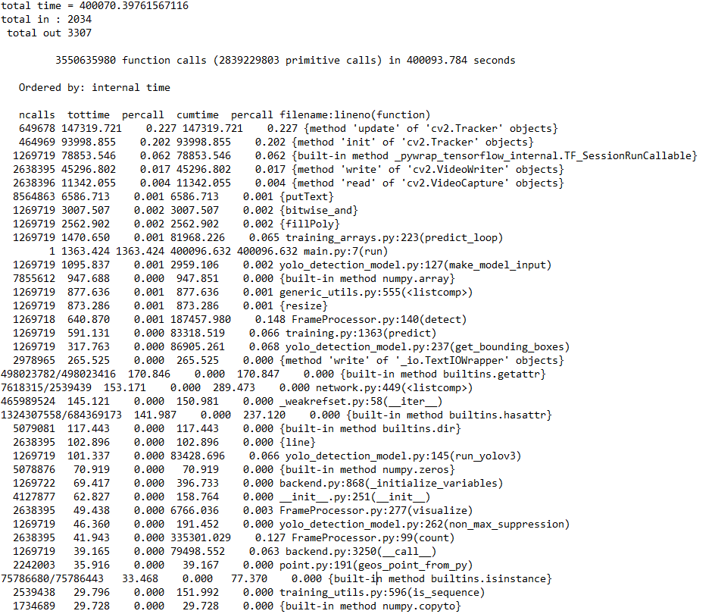

Figure 16 - Timing the different functions (using cProfile) – top of the list.

*Note that the real detection computations are made on the GPU and are not listed here, this checks only CPU computations. We haven’t implemented the detector itself and had no control over its performance.

The most expensive actions are by far the methods required by the tracker.

Next, are the actions required by modifying the frame (using OpenCV’s ‘write’, but also putText, fillPoly etc…): Adding the counting line \ ROI to frame, colouring it, putting a bounding box around a person, adding text to screen. This shows that not showing a modified window should be preferred if CPU demands are needed to be lowered.

Lastly, the actions surrounding the detection: wrapping the input are taking the third most CPU resources.

The rest of the functions have an almost insignificant impact on performance.

# Overview of algorithms and models used

*Both detector models we used were pre-trained on the COCO dataset:

[http://cocodataset.org/](http://cocodataset.org/#format-data)

## YOLOv3 (You Only Look Once version 3)[2]

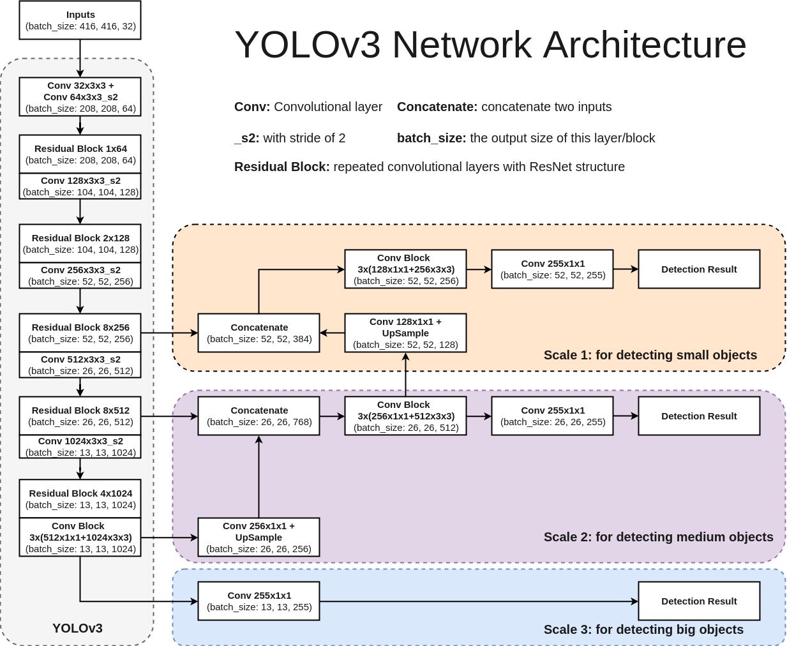

Figure 17 - YOLO Architecture diagram

YOLO is a feature-learning based network that adopts fully convolutional layers underlying architecture. No fully-connected layer is used. This structure makes it possible to deal with images with any sizes. Also, no pooling layers are used. Instead, a convolutional layer with stride 2 used to down sample the feature map (stride of the network or a layer is defined as the ratio by which it down samples the input), passing size-invariant feature forwardly.

It is desirable that the network would detect objects of all sizes – both small and large. As the network goes deeper, its feature map gets smaller. That is to say, the deeper it goes, the harder it is to detect smaller objects.

Thus, object detection is carried out on different features maps in order to catch various scales. YOLOv3 achieves this by using FPN (Feature Pyramid Network): the prediction is done on feature maps at different depths, with further features being utilized by up sampling the feature map to be merged with the current feature map.

With this technique, the network is more capable to capture the object’s information, both low-level and high-level.

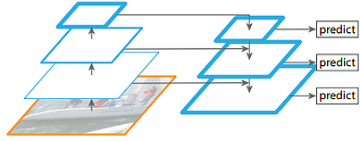

Figure 18 – FPN

The classification is made by 1x1 convolutional layer with a logistic function. Previous versions of YOLO used softmax instead, but it meant we had to assume that each output only belonged to **one** of the classes. However, some datasets or cases have labels which are similar (i.e. Woman and Person), thus the training with softmax might not let the network generalize the data distribution well.

## Mask R-CNN[3]

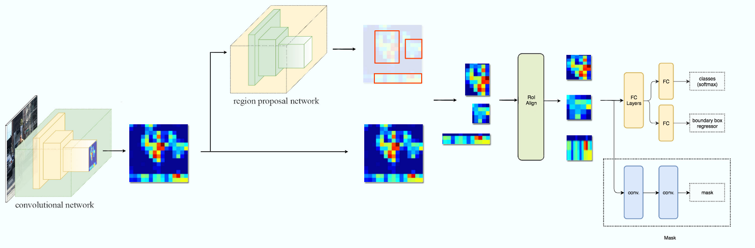

Intuitively, Mask R-CNN is a network that resembles a tree, where the nodes are Deep Neural Net components, each with a specific task:

1. The first component is a CNN (which is the “backbone” network) which should be some state of the art feature extractor like ResNet (ResNet-101 in our case).
2. The second component would be the RPN (Region Proposal Network) Which shares convolutional layers with the backbone using a FPN (Feature Pyramid Network).

* FPN improves region proposal and is more accurate than using only the last feature map layer of the backbone.

1. The third component is FC (Fully Connected) that performs both regression on the bounding boxes and classification inside the regions.
2. The fourth part is the masking CNN which is basically a binary classifier that indicates for each pixel in the region whether it is a part of an object or not.

## Centroid Tracking Algorithm[4]

The Centroid Tracking algorithm is the most basic tracking algorithm that can be imagined:

Every frame a detector is used (might be a DNN or something much more lightweight to such as SVM, Haar Cascade etc… only to detect objects on the screen), it computes all of the detected objects’ centroids from their bounding boxes.

For the next frame, it calculates the objects detected again. Then, it calculates the Euclidean distance between each object from the previous frame and the current one.

The closest object on the current frame to an object from last frame is probably the same object, and as such the object’s location is updated to the new one.

If there are more objects than there were before, it means that new objects have appeared on screen, and the ones most far from the existing objects are assigned new unique IDs of their own.

**ID #1**

**Best candidate to be the same object – shortest Euclidean distance**

## CSRT Tracking Algorithm[5]

Discriminative Correlation Filter with Channel and Spatial Reliability (DCF-CSR), more commonly known as CSRT, learns a set of filters that represent an object and uses them to find the most correlated point in the proximity of the position of the track on the previous frame.

A spatial reliability map is used for adjusting the filter support to the part of the selected region from the frame for tracking. This ensures enlarging and localization of the selected region and improved tracking of the non-rectangular regions or objects.

It uses only 2 standard features: HoGs (Histogram of oriented gradients) and Colornames.

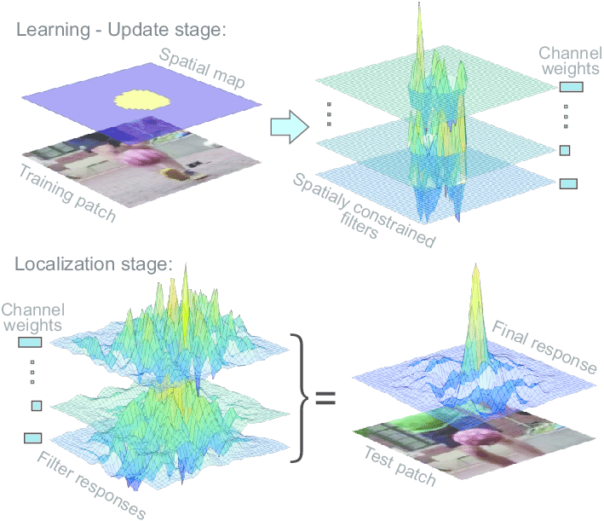

# Conclusions

* The system achieves high accuracy without being heavy on computational resources (relatively to the task). If we were to summarize all people entering and exiting in all of the test videos, we would stand on 97% accuracy in counting.
* We avoided overfitting to any specific library by limiting the amount of factors we could change (the most significant one being MCDF).
* Our benchmark test videos were 12 FPS, but higher FPS should provide better accuracy (though it might be slow the system, and will change the optimality of the parameters we’ve found).

# Further Work and Suggestions

* Further work: Setting up the system for the customers (already discussed with customers).
* Further work: In depth tutorial for the system (and its internal code) with the customers.
* Increasing FPS of videos from cameras and adjusting the system’s parameters accordingly to increase accuracy even further.
* Changing cameras positions to center bottlenecks. Optionally, adding a physical bottleneck if the entrance lacks any.
* Use even a better detector or tracker in the future when such will emerge. The system was built in a modular way to allow the easy switching of models.

# References

Mask R-CNN paper: <https://arxiv.org/abs/1703.06870>

Matterport Mask R-CNN: <https://github.com/matterport/Mask_RCNN>

YOLOv3 paper: <https://arxiv.org/abs/1804.02767>

schneider128k’s YOLOv3 implementation: <https://github.com/schneider128k/yolov3-keras>

COCO dataset: [http://cocodataset.org](http://cocodataset.org/#home)

Counting code is based on nicholaskajoh’s vehicle counting code: <https://github.com/nicholaskajoh/ivy>

1. Recommendations for using counting ROI.
2. *We have used schneider128k YOLOv3 implementation for python 3, Keras (TensorFlow backend)*

   <https://github.com/schneider128k/yolov3-keras>
3. *We have used MatterPort’s Mask R-CNN implementation for python 3, Keras and TensorFlow*

   <https://github.com/matterport/Mask_RCNN>
4. We have used a simple implementation of the algorithm from <https://www.pyimagesearch.com/2018/07/23/simple-object-tracking-with-opencv/>
5. We have used Open-CV’s implementation of the CSRT tracking algorithm